Class Test 1
M.Raghavendra
192325022

Regular Expressions and Validation in JavaScript
1. Student Registration Validation: Write a JavaScript program to validate a student registration form containing a full name, email address, 10-digit mobile number, date of birth in DD-MM-YYYY format, and password. The password must contain at least one uppercase letter, one lowercase letter, one digit, and one special character, with a minimum length of eight characters.
Ans:
Code:

<!DOCTYPE html>
<html>
<head>
<title>Student Registration</title>
</head>
<body>
<h2>Student Registration Form</h2>
<form onsubmit="return validateForm()">
Full Name: <input type="text" id="name" required><br><br>
Email: <input type="text" id="email" required><br><br>
Mobile: <input type="text" id="mobile" required><br><br>
DOB (DD-MM-YYYY): <input type="text" id="dob" required><br><br>
Password: <input type="password" id="password" required><br><br>
<input type="submit" value="Register">
</form>
<p id="result"></p>
<script>
function validateForm() {
let name = document.getElementById("name").value.trim();
let email = document.getElementById("email").value;
let mobile = document.getElementById("mobile").value;
let dob = document.getElementById("dob").value;
let password = document.getElementById("password").value;
let result = document.getElementById("result");
if (name === "") {
alert("Enter full name");
return false;
}
if (!/^[^\s@]+@[^\s@]+\.[^\s@]+$/.test(email)) {
alert("Enter a valid email");
return false;
}
if (!/^\d{10}$/.test(mobile)) {
alert("Mobile must contain 10 digits");
return false;
}
if (!/^(0[1-9]|[12]\d|3[01])-(0[1-9]|1[0-2])-\d{4}$/.test(dob)
|| !validDate(dob)) {
alert("Enter a valid DOB in DD-MM-YYYY format");
return false;
}
if (!/^(?=.*[A-Z])(?=.*[a-z])(?=.*\d)(?=.*[^A-Za-z0-9\s])\S{8,}$/.test(password)) {
alert("Password needs 8 characters, uppercase, lowercase, digit and special character");
return false;
}
result.innerHTML = "Registration Successful!";
result.style.color = "green";
return false;
}
function validDate(dob) {
let p = dob.split("-");
let d = new Date(+p[2], +p[1] - 1, +p[0]);
return d.getFullYear() === +p[2] &&
d.getMonth() === +p[1] - 1 &&
d.getDate() === +p[0];
}
</script>
</body>
</html>

Output:
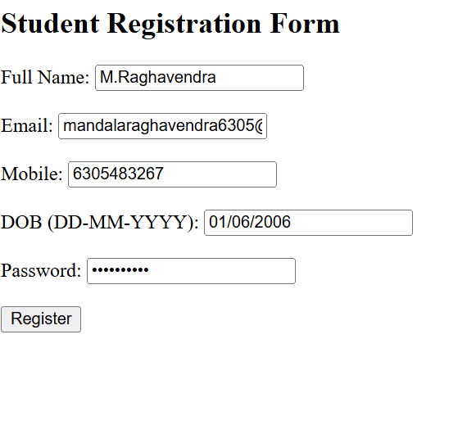

2. Password Strength Validation: Write a JavaScript program to validate a password with the following rules: minimum 10 characters, at least two digits, one uppercase letter, one lowercase letter, one special character, and no whitespace. Display an appropriate error message for each failed condition.
Ans.
Code:

<!DOCTYPE html>
<html>
<head>
<title>Password Validation</title>
</head>
<body>
<h2>Password Strength Validation</h2>

Enter Password:
<input type="password" id="pwd">
<button onclick="validatePassword()">Check</button>

<p id="result"></p>

<script>
function validatePassword() {
let p = document.getElementById("pwd").value;
let errors = [];

if (p.length < 10)
errors.push("Minimum 10 characters required.");

if ((p.match(/\d/g) || []).length < 2)
errors.push("At least two digits required.");

if (!/[A-Z]/.test(p))
errors.push("At least one uppercase letter required.");

if (!/[a-z]/.test(p))
errors.push("At least one lowercase letter required.");

if (!/[^A-Za-z0-9\s]/.test(p))
errors.push("At least one special character required.");

if (/\s/.test(p))
errors.push("Whitespace is not allowed.");

let result = document.getElementById("result");

if (errors.length > 0) {
result.innerHTML = errors.join("<br>");
result.style.color = "red";
} else {
result.innerHTML = "Password is Strong!";
result.style.color = "green";
}
}
</script>
</body>
</html>

Output:
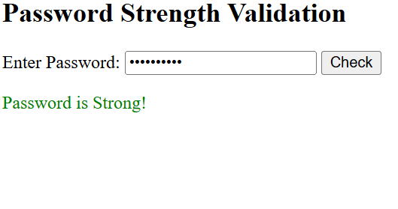
3. Email Address Validation: Write a JavaScript program to validate email addresses according to these rules: the address must contain exactly one @, a non-empty username, a domain name, and a valid-looking extension of at least two letters. Reject spaces and consecutive dots.
Ans:
Code:
<!DOCTYPE html>
<html>
<head>
<title>Email Validation</title>
</head>
<body>
<h2>Email Address Validation</h2>

Enter Email:
<input type="text" id="email">
<button onclick="validateEmail()">Validate</button>

<p id="result"></p>

<script>
function validateEmail() {
let email = document.getElementById("email").value;
let result = document.getElementById("result");

let pattern = /^[A-Za-z0-9._%+-]+@[A-Za-z0-9-]+(\.[A-Za-z0-9-]+)*\.[A-Za-z]{2,}$/;

if (email.includes(" ")) {
result.innerHTML = "Error: Spaces are not allowed.";
result.style.color = "red";
}
else if ((email.match(/@/g) || []).length !== 1) {
result.innerHTML = "Error: Email must contain exactly one @.";
result.style.color = "red";
}
else if (email.includes("..")) {
result.innerHTML = "Error: Consecutive dots are not allowed.";
result.style.color = "red";
}
else if (!pattern.test(email)) {
result.innerHTML = "Error: Enter a valid email address.";
result.style.color = "red";
}
else {
result.innerHTML = "Valid Email Address!";
result.style.color = "green";
}
}
</script>
</body>
</html>

Output:
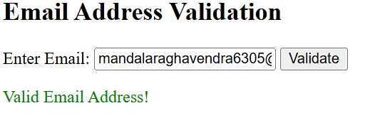
4. Username Validation: Write a JavaScript program to validate a username that must start with a letter, contain only letters, digits, and underscores, have a length of 6–15 characters, and must not end with an underscore or contain consecutive underscores.
Ans:
Code:
<!DOCTYPE html>
<html>
<head>
<title>Username Validation</title>
</head>
<body>
<h2>Username Validation</h2>

Enter Username:
<input type="text" id="username">
<button onclick="validateUsername()">Validate</button>

<p id="result"></p>

<script>
function validateUsername() {
let u = document.getElementById("username").value;
let result = document.getElementById("result");
let errors = [];

if (!/^[A-Za-z]/.test(u))
errors.push("Username must start with a letter.");

if (!/^[A-Za-z0-9_]+$/.test(u))
errors.push("Only letters, digits, and underscores are allowed.");

if (u.length < 6 || u.length > 15)
errors.push("Username must be 6 to 15 characters long.");

if (u.endsWith("_"))
errors.push("Username must not end with an underscore.");

if (u.includes("__"))
errors.push("Consecutive underscores are not allowed.");

if (errors.length > 0) {
result.innerHTML = errors.join("<br>");
result.style.color = "red";
} else {
result.innerHTML = "Valid Username!";
result.style.color = "green";
}
}
</script>
</body>
</html>

Output:
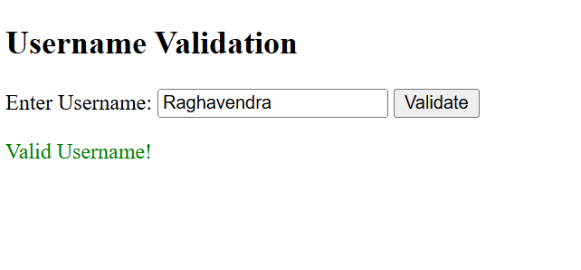
5. Extract and Analyse Data: Write a JavaScript program to extract all mobile numbers, email addresses, and dates from a paragraph using regular expressions. Display each category separately.
Ans:
Code:

<!DOCTYPE html>
<html>
<head>
<title>Extract and Analyse Data</title>
</head>
<body>
<h2>Extract and Analyse Data</h2>

<textarea id="text" rows="5" cols="50">Contact Rahul at 9876543210 or rahul@gmail.com.
His friend Sita uses 9123456780 and sita@yahoo.com.
Dates: 15-08-2005 and 20-12-2004.</textarea>
<br><br>

<button onclick="extractData()">Extract Data</button>

<h3>Mobile Numbers</h3>
<p id="mobile"></p>

<h3>Email Addresses</h3>
<p id="email"></p>

<h3>Dates</h3>
<p id="date"></p>

<script>
function extractData() {
let text = document.getElementById("text").value;

let mobiles = text.match(/\b[6-9]\d{9}\b/g) || [];
let emails = text.match(/\b[A-Za-z0-9._%+-]+@[A-Za-z0-9.-]+\.[A-Za-z]{2,}\b/g) || [];
let dates = text.match(/\b\d{2}-\d{2}-\d{4}\b/g) || [];

document.getElementById("mobile").innerHTML =
mobiles.length ? mobiles.join("<br>") : "No mobile numbers found";

document.getElementById("email").innerHTML =
emails.length ? emails.join("<br>") : "No emails found";

document.getElementById("date").innerHTML =
dates.length ? dates.join("<br>") : "No dates found";
}
</script>
</body>
</html>
Output:
